Expression Animation System

Run-Time Classes & Data Structures



Document Sign–Off
Project Name | Expression Animation System |  | Technical Director | Neall Verheyde
Document | Technical Analysis |  | Author | Pamela Chow

This publication was produced by Radical Entertainment Ltd.

© 2001 Radical Entertainment Ltd. All Rights Reserved.

The information contained herein is the property of Radical Entertainment Ltd. Except as specifically authorized in writing by Radical Entertainment Ltd., the holder of this document shall: i) keep all information contained herein confidential, and ii) protect the information, in whole or in part, from disclosure and dissemination to all third parties.

Date of Issue | Document ID | Brief Description
Jan2, 2001 |  | Release 1
Dec 21, 2001 |  | Draft 2
Nov 15, 2001 |  | Draft 1

Printed in Canada

Table Of Contents
1 About This Document 1
1.1 Related documents 1
2 Introduction 1
2.1 History 1
2.1.1 Simplification of blending equation 2
2.1.2 Support for multiple keys per expression 3
2.1.3 Deprecated Features 3
3 Data Structures 4
3.1 The Expression Group 4
3.2 Offset Lists 6
3.3 Animation Data 7
3.4 Mixers and FrameController Data 7
4 Current Class Hierarchy 9
4.1 tExpressionGroup and tExpressions 9
4.2 Expression Mixers 10
4.2.1 Data table for vertex offsets calculation 12
4.3 Expression Frame Controller 13
4.4 Offsetlists and PrimGroups 14
5 Functional Scenarios 15
5.1 Art Pipeline Considerations 16
6 Future Work 16
6.1 Run-time 16
6.2 Toollib 17
6.3 Feature Requests 17
7 Conclusion 18
8 Interesting Links 18

List of Figures
Figure 1 Format of tlExpressionChunks 6
Figure 2 Format of tlOffsetListChunks 7
Figure 3 Format of expression animation channels 8
Figure 4 Format of tlExpressionMixerChunk 9
Figure 5 Format of an expression tFrameControllerChunk 9
Figure 6 Overview of Run-time Classes 10
Figure 7 tVertexOffsetExpressionMixer is a tExpressionMixer 12
Figure 8 tExpressionAnimationController 15
Figure 9 Offset data is stored in sub-chunks of the tlSkinChunk 16

About This Document
This document is submitted in part as requirement for successfully completing my co-operative work term at Radical Entertainment. The desired outcome of this document is to pass on the helpful information to the next person to work on the run-time component of Pure3D Expression Animation system. This system has reputation for being unduly complex. It is my hope that this document will clarify the key issues, and important implementation details, and highlight the pitfalls of the expression system.

Related documents
Technical Design: Pure3D Expression Animation System
Author: Katrina Archer

Introduction
The Expression Animation System is synonymous with vertex offset animation. A mesh is animated, or deformed, by applying offsets to its vertices. These offsets are associated with a key represented by a normalized value –1.0 to 1.0. The shape of the mesh can therefore change over time by specifying a value in this range. The key values (e.g. 0.5) are associated with a set of vertex offsets. P3D runtime performs a linear interpolation of vertex offsets between key values to create smooth animation.
Another dimension is added to this simple idea by defining the concept of an Expression. An Expression is a set of keys (each associated with vertices and their offset). Because the shape of a mesh can be affected by a number of expression, we need to blend or mix the vertex offsets contributed by each expression. The details of the vertex offset calculation and mixing is explained in section “ Simplification of blending equation”.

History
This section summarizes the major changes that were implemented since the original technical design. changes are as follows:
- Simplification of blending equation
- Support for expressions with multiple keys
- Deprecated features

Simplification of blending equation
The blending equation is used to combine the offset contributed by several expressions Blending is performed in 2 stages. All expressions affecting a target mesh are defined as being of one of 3 blendstages (blendstage 0, 1 and 2). First, all expressions within a blendstage are combined to produce a offset contribution for each blendstage. The offset contributions of all blendstages are then summed. This 2-stage blend system is still used. However, the current implementation differs from the blending equation proposed in the technical design proposed by Katrina Archer in that it does not use a separate weighting factor for each expression. Consider the following example.
Assume we have 2 expressions: Smile and Sad. Suppose the current states of the expression is given in table below. The state value indicates the degree of the expression for example, if the smile expression is defined in the range 0 to 1 then 0.5 is half a smile. The Smile and Sad expressions are members of Blendstage1, whereas Eyebrow-surprise and Eyebrow-angry are members of another blendstage. Further assume that these expressions affect the position of one vertex only, although in reality expressions are usually associated with offset values for a subset of vertices in the target mesh. Vertex Offsets are represented by a vector (x, y , z) displacement from the vertex position in the neutral mesh shape.
Expression | State | Weight | Blend Stage | Vertex Offset
Smile | 0.5 | 0.3 | Blendstage1 | V_{smile}
Sad | 0.25 | 0.7 | Blendstage1 | V_{sad}
Eyebrow-suprise | 0.5 | 0.8 | Blendstage2 | V_{suprise}
Eyebrow-angry | 0.75 | 0.2 | Blendstage2 | V_{angry}

Original blend equation
Blended offset = { (0.3 * 0.5 * Vsmile + 0.7 * 0.25 * Vsmile ) / (0.3 + 0.7) } +
{ (0.8 * 0.5 * Vsurprise + 0.2* 0.75 * Vangry ) / 0.8 + 0.2) }
The general equation for Vertex n:
Σ _{b}{ Σ _{i} [ State_{i} * V_{(n,i)} * Weight_{i} ] / Σ _{i} Weight_{i} }
b = { blendstages: 0, 1, 2}
i = {expressions }
V_{(n,i)} = vertex offset for Vertex _{n} in Expression _{i}
Implemented blend equation:
Blended offset = (0.5 * Vsmile + 0.25* Vsad )/ (0.5 + 0.25) + ( 0.5 Vsurprise + 0.75 Vangry) / (0.5 + 0.75)
The general equation for Vertex n:
Σ _{b}{ Σ _{i} [ State_{i} * V_{(n,i)}] / Σ _{i} State_{i} }
b = { blendstages: 0, 1, 2}
i = {expressions }
V_{(n,i)} = vertex offset for Vertex _{n} in Expression _{i}

The current blend equation does not use the Weight but instead uses the State value to represent the relative weighting of an expression with respect to other expressions in the same blendstage. The above equations also show that expressions within a blendstage are averaged whereas expressions in different blendstages are additive. This implies that expressions that are “mutually exclusive” should be in the same blendstage category . The term “mutually exclusive” is used to describe expressions where more of one expression necessarily implies less of the another. For example having more of an 0-mouth shape necessarily means that the face can make less of E-mouth shape are mutually exclusive shapes – hence you would not want to add “o” shape to and “e” mouth, therefore they should be in the same blendstage. By contrast, expressions that do not have this relationship should be in separate blendstages

Support for multiple keys per expression
Support for multiple keys was added by my predecessor Richard O’Grady. Pamela Chow further extended this feature to support negative key values.
This feature can significantly increases the size of the data structures used by the expression system. Since for each additional key an entire set of vertex indices and vertex offsets must be exported and loaded in the run-time system. However, this feature allows artists to define expressions that require vertices to trace a non-linear path between two extreme values of an expression ( 0 and 1.0 or –1.0).
Support for negative keys are useful for expressions which can meaningfully be represented by negative keys. For example, the eye-brow up and eye-brow down expressions can be encoded as keyshape at –1.0 and 1.0 of the same expressions rather than as two separate expressions. Another use for negative keys is to define a negative limit for each expression. Even when all expressions have no negative keys, the animation curve in Maya can contain negative expression values because it uses a spline-based algorithm to interpolate between keyframes. If no negative keyshape is defined for this expression, the run-time system (and the deformer plug-in) will compute the vertex offsets for negative expression values as a positive value and then multiply the offset by –1. This will often result in unintended shape. To avoid this problem users may choose to define a negative limit for all expressions.

Interpolating between positive and negative keys
When support for negative keys was added, we needed to decide how to interpolate between a negative and a positive keyshape. There was 2 choices – interpolation through the neutral mesh shape at key value of 0.0, or interpolate between the negative and positive key shapes without considering the neutral mesh shape. The currently the run-time and deformer plug-in implements the former. The key value of 0.0 implies the neutral mesh shape. Hence any expressions with a value of 0.0 at a given time T, corresponds to an offset of (0.0. 0.0, 0.0) for all vertices. Since vertex offsets for the key value of 0.0 is always a zero vector, the vertex offsets and indices for 0. and not exported but implied in the run-time system.

Deprecated Features
We no longer support the concept of expression presets and Hspline expression data.

Data Structures
The data required by the expression animation system is extensive. The key to understanding the expression animation system, is to understand the data used by this system. This section explains the 3 data components and how they are represented in the p3d file and consequently in the run-time. The components are explained in the sections that follow.

The Expression Group
The expression group is a set of expressions. It defines all possible expressions that a given mesh target can have. The expression group is defined not only by the number of these expressions and their names (e.g. smile, sad) but by the number of keys defined for each expression in the set. The keys in each expression are the key shapes that the target mesh can assume: these shapes are assigned a value between –1 and 1. Two expression groups cannot be considered equivalent if they do not have at least the same number of expressions, and the same number of keys in each expression. The order of the expressions in the group, and the vertex indices and vertex offsets must also be the same.
In p3d file format, the expression group is implemented by the tlExpressionGroup and tlExpressionGroupChunk respectively. In the p3d file, each tExpressionGroup is a set of expressions represented by tlExpressionChunks (previously called tlVertexOffsetExpressionChunk16). Notice that each expression, is associated with a blendstage. In the example below, all 19 expressions in Mike_P3DShapes group are in the same blendstage – blendstage 0. Blend stages are used in the blending equation described in Section 2.1.1 Simplification of blending equation.
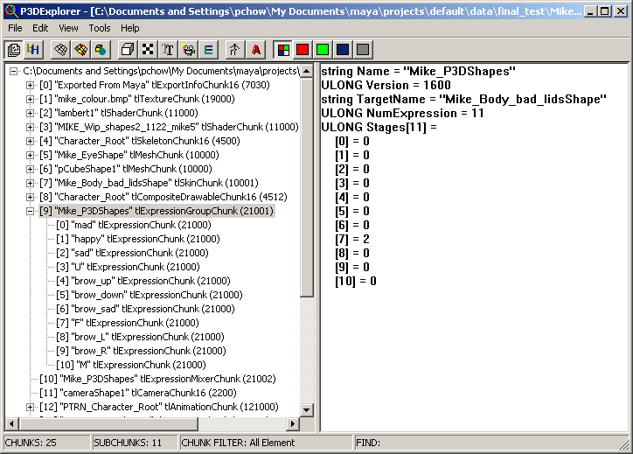

Each tlExpressionChunk contains an array of floats (as shown in the Figure 1 below). These floats represent the key values for each shape defined in this expression. For example, if the artist has defined eyebrow-lift expression such that eyebrow is arched upwards when the key value is 1.0 and pulled down at key value is –1.0, then the Keys array will contain -1.0, and 1.0 respectively. Note, that the exporter plug-in sorts the key values in ascending order during export.
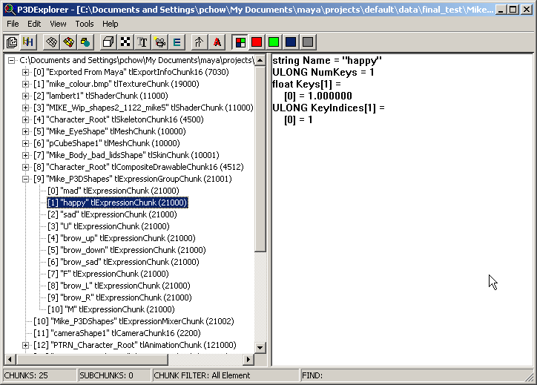
Figure 1 Format of tlExpressionChunks
Every key must be associated with a set of Vertex-Offset pairs (i.e. a vertex index and its offset vector from its neutral mesh position). We refer to Vertex-Offset pairs as offset lists. Offset lists are represented in the p3d file format by tlOffsetListChunks, and in run-time as tOffsetLists. The Indices array in the tlExpressionChunk gives the index of the corresponding tlOffsetlistChunk for this key. During export, every offset list exported is given an index number from 0 to N, where N+1 is the number of offset lists exported. In Figure 1 above, the tlExpression chunk “happy” has a single key shape at of 1.000. The offset list for this keyshape has an index of 1.
tlOffsetListChunks are sub-chunks of the tlExpressionAnimOffsets chunk (a sub-chunk of tlSkinChunk). Offset lists are the explained in the next section.

Offset Lists
Offset Lists contain information about the vertex and the vertices that they must be applied to for each key shape in an expression. Offset Lists are represented in p3d file by tlOffsetListChunk.
The Key Index field in this chunk links the offset list to the key shape that it defines. In Figure 2 , the offset list whose index is 1 corresponds to the index for key[0] in “happy” expression.
A mesh is composed of several primgroups. Because the vertices affected by that key shape may be members of several primgroups, there can also be several offset lists for the same key value each belonging to a different primgroup. Hence, it is necessary to indicate the primgroup that an offset list affects: this is indicated in the PrimGroupIndex field (not shown).
Each tlOffsetListChunk contains an array of tlVtxOffsets: tlVtxOffsets store a vertex index and a vector that represents the offset for this vertex. The vertex index refers to its ordinal position within its primgroup (not the Maya vertex index).
tlOffsetListChunks are sub-chunks of the tlExpressionOffsetsChunk. This data chunk provides the following information about its contents – the number of offset lists it contains, the number of primgroups that are affected by the offset list sub-chunks, and an array containing the indices of these primgroups.
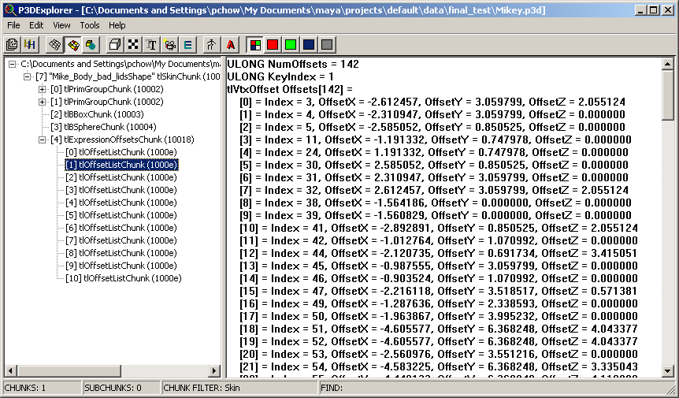
Figure 2 Format of tlOffsetListChunks

Animation Data
The third data component for facial animation is the time-based parameters. Facial animation is driven by the value of each expression as a floating point value (in the range –1 to 1) at a given keyframe. The key value of each expression over time is exported in the tlAnimationGroup chunk as shown in Figure 3.
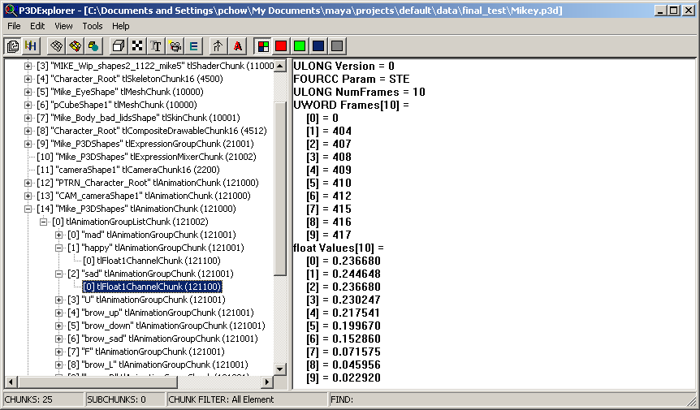
Figure 3 Format of expression animation channels

Mixers and FrameController Data
There is 1-to-many relation between expression Group – and animations that use expressions defined in an expression Group. However, there a 1-to-1 relation between expression key shapes and the offset lists stored in the tlSkinChunk. For each keyshape there must be one offsetlists.
In addition to the data chunks already discussed, the exporter also exports 2 other file chunks used by the expression system. These chunks specify a combination of the 3 data components (expressions, offset lists and animation) at load time. The two other chunks are:
- tlExpressionMixerChunk
Associates a target, typically a skin and its offset lists , with an expression group.
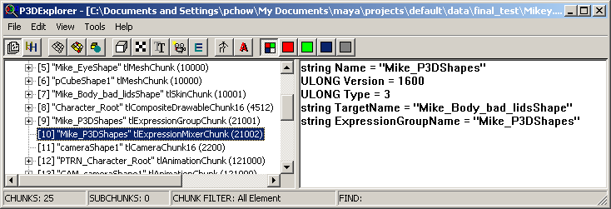
Figure 4 Format of tlExpressionMixerChunk
- tlFrameControllerChunk
Associates a tlFrameController object with a mixer object and an expression animation chunk.
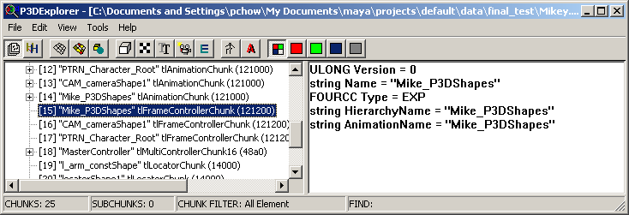
Figure 5 Format of an expression tFrameControllerChunk
Since there is a one-to-one relation between a target skin or mesh and an expression group, it is reasonable to require that the tlExpressionMixer should be exported for every animatable character. However, because similar characters can share the same expression group (i.e. the same expression structure), it may be desirable to create only 1 instance of an expression group that is shared by several mixers.
The tlFrameControllerChunk is primarily intended to be used by the p3dViewer. To play a different animation than the one bound to the framecontroller at load-time, you can assign a new animation to the frame controller before calling its update method.
The game programmer can create run-time instances of these structures and modify the data components that they point to. For example, you can create a tVertexOffsetExpressionMixer, and set its target and its expression group. Likewise, you can create a tExpressionFrameController, and set the animation and the mixer for this instance. Note however, that is difficult as you must ensure that data components compatible. Currently, the run-time system does not tolerate many data errors. This raises the question of whether the right balance of error detection and tolerance has been implemented.

Current Class Hierarchy
This section describes the run-time classes used by the expression animation system. A high-level overview of system is shown in Figure 6. This figure shows the key run-time classes and the key methods and attributes.
The tVertexExpressionMixer is the work horse of the system. It’s Update method performs all the computation needed to determine the new position of all affected offsets at a given time. Note that the Mixer object contains a reference to the expression group object and to the drawable object, where as the tExpressionFrameController objects has access to these data components indirectly through a pointer to the mixer object. However, the tExpressionFrameController has direct access to the animation data in its PlayInfo structure.
The following sections will examine each class in greater detail.
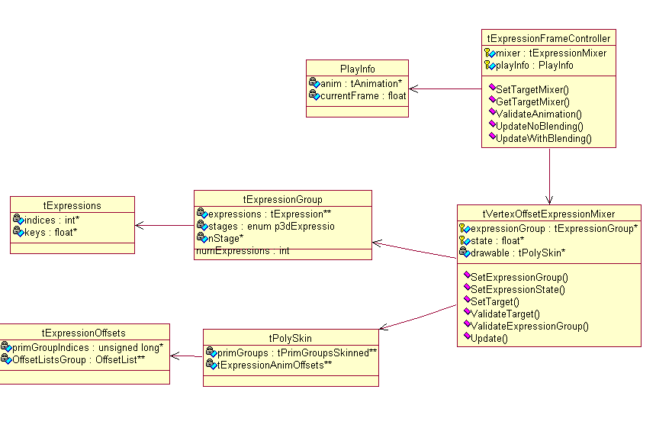
Figure 6 Overview of Run-time Classes

tExpressionGroup and tExpressions
An expression group is a container for all expressions that apply to a target. The expression group has an array of pointers to tExpression objects and a corresponding array of expression stages. The Expression stages are enumerated type from 0 to 2. Expressions are used in the blending algorithm, see 2.1.1 Simplification of blending equation. Blend stages are decided when the expressions are set up and are not an animatable attribute.
In addition to expressions, the expression group also contains the UID of a target that it is bound to at export. The UID of the target mesh is useful only when each character will have its own instance of an expression group. In this case, the field can be used in the art pipeline to associate an expression group with a target mesh. The UID field is not currently used at run-time to test for compatiblity between the expression group and the target.
tExpressionGroup objects are derived from tEntity and are stored in the Pure3D inventory. However, tExpression are not stored in the Pure3D inventory but in a specialized inventory. This is to minimize namespace pollution in the inventory and more importantly allows multiple expression groups to use the same names for the expressions they contain. The later facilitates the use of a set of standardized visemes, phoneme, and emotions for all characters.

Expression Mixers
The tExpressionMixer is the abstract base class. It provides accessors for setting the expression group, the target mesh, and the current expression values (or states). The tExpressionMixer class is extended by tVertexExpressionMixer and tPoseExpressionMixer. tPoseExpressionMixer is not currently used.
The main of function the tVertexOffsetExpressionMixer class are the following:
- Calculate the offsets for vertices that are affected by expressions.
The Update() method of tVertexOffsetExpressionMixer performs all the vertex offset calculations and blending. The primgroups which are affected by expression animation are those which have tOffsetLists which affect them. The Update method uses a large data table compiled from data from the mixer’s expression group and from the mixer target’s offset lists. This data structure is discussed in more detail in 4.2.1 Data table for vertex offsets calculation.
- Associate an expression group with a target
Two member variables in the tVertexOfsetExpressionMixer are a pointers to a tExpressionGroup and a tDrawable object. When the tExpressionMixerLoader encounters a tlVertexExpressionMixerChunk, it creates an instance of the tVertexOffsetExpressionMixer. Data in the tlVertexExpressionMixerChunk is used to set the expression group and the target tDrawable by calling the SetExpressionGroup and SetTarget methods.
Since this method is public, the expression group can also be set at run-time. Likewise, a public method called SetTarget(tDrawable* ) allows you to set mixer’s target mesh at run-time. A precondition for SetTarget() is that the tDrawable object must be a tPolySkin must have an tExpressionOffsets object that contains at least one tOffsetList object.
To modify the position of vertices, the mixer needs to get the vertex positions of the neutral mesh. After calculating the vertex offsets for each update loop, the mixer adds the vertex offsets the neutral mesh vertex positions. Hence the SetTarget() method calls the tPrimGroupSkinned::GetVertices() to get the neutral mesh vertex positions.
- Ensure that the expression group and the target of the expression animation are compatible.
This is currently performed by two methods: ValidateExpressionGroup() and ValidateTarget(). The original intention is that the ValidateExpressionGroup method should “determine whether the expression group operates on the correct target object type for the mixer” (Pure3D Expression Animation System, Katrina Archer) . However, the current implementation only performs superficial checks. Currently, the ValidateExpressionGroup() method only checks that the expressionGroup for this mixer contains references to tExpression objects – it does not verify that the expressionGroup is valid for the current target.
The function of ValidateTarget() is to “ to ensure that it (the target) is compatible with the target of the expression group.” This is not the currently implemented. Initially, the plan was to use the target drawable UID in tExpressionGroup class to validate the tDrawable object being set by the SetTarget method. However, asynchronous loading of inventory sections means that the drawable object may not be loaded at the time when ValidateTarget() is called. The only check that is currently performed by ValidateTarget() is to ensure that the drawable is not NULL.
The ResetToNeutral() method resets all expression states to zero, the neutral mesh shape.
SetExpressionState() is called by the tFrameController::Update() method. The SetExpressionState() sets the current value of each expression, and sets the mixerReady flag to false. When the mixerReady flag is false indicates, the mixer is “dirty” and should recalculate its vertex offsets in the next call to its Update method. When the flag is true, the expression states have not changed since the last update and the Update method should not recomputed the vertex offsets. The SetExpressionState() is a public method that could potentially be called by event system to set the mesh to a desired shape.
The GetVertexOffsets() method is a new method that allows PDDI or other entity to query the mixer for the current vertex offset. If the mixerReady flag is false the GetVertexOffsets method will call the mixer Update method before returning the vertex offsets for all vertices in the specified primgroup.
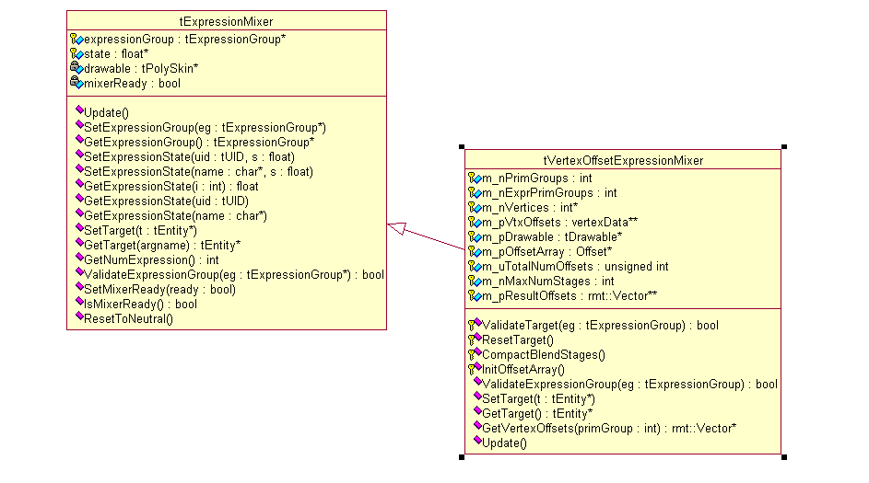
Figure 7 tVertexOffsetExpressionMixer is a tExpressionMixer

Data table for vertex offsets calculation
InitOffsetArray() method assembles the table of data used to compute vertex offsets. It assembles from the vertex-offset pairs stored in tOffsetLists. The following pseudocode shows how the data table is populated.
//for each key in the expression group find the corresponding offset list
{
//if offset list is found
// for each vertex-offset pair in the offset list
//Create a record in the table containing this information
// 1. vertex Data - information about the original position of the vertex;
//2. expression Index (e.g. (int) 1 );
//3. key value (e.g. 1.0f);
//4. Offset vector (x,y,z );
//if offset list is not found
// continue
}
The size of the table is a multiple of the number of expressions, expression keys and vertices. To be exact it is
Size of data table = Σ _{e} ( Σ _{k} v_{k} )
where:
e is an expression index 0 to n where n+1 is the number of expressions in the expression group
k is key index for keys in expression e. The key index is zero based index from 0 to m where m+1 is the number of keys in an expression e.
v_{k} is the number of vertices in the offset list associated with a particular key.
From this equation the data structure used to compute vertex offsets is n³ data structure. The size of data table is approximately E * K * V, where E is the average number of expressions, K is the average number of keys per expression, and V is the average number of vertices affected by all keys in an expression group.
Because the data table combines information about the target mesh (namely its offset list data) and expression structure (expression index and key value), this table should be re-initialized every time the target of the mixer is changed or the expression group for this mixer is changed.
The algorithm for assembling the data table tolerates the data errors as follows:
- if there are no expression keys defined for an offset list, the offset list is ignored.
- If there are expression keys for which no offset lists are defined, the expression key is ignored.
This means that if the target drawable object has no offset lists, or if the expression group is not the correct one for this target, then no error messages are displayed but the animation will not play. For debugging purposes, it may be desirable to enable a diagnostic mode that detects these data errors. This has been partly implemented for version 16.

Expression Frame Controller
The function of tExpressionFrameController is to update the tVertexOffsetExpressionMixer object during the each scene update loop. The tExpressionFrameController methods, UpdateNoBlending() and UpdateWithBlending(), compute the current state (i.e. value) of each expression and calls the mixer’s update method. The expression states are stored as an array of floats in the tVertexOffsetExpressionMixer object.
The two notable methods are:
- SetTargetMixer( )
- SetAnimation( )
- ValidateAnimation( ).
The SetTargetMixer() is called by the loader to initialize the mixer attribute in the expression frame controller. However, because this method is public it can be used to change the mixer assigned to a tExpressionFrameController object. You may not get a desirable result unless you are know that the mixer is correct for the animations that you intend to play. A mixer can be incorrect if the animations assigned to the frame controller contains expression channels that are not defined by the mixer’s expression group. This error will cause an assertion when the animation is set using SetAnimation().
SetAnimation() is used to play different expression animations using the same frame controller. When SetAnimation is called the ValidateAnimation() method is called. Currently, this method checks all the name of each animation groups in the animation (animation groups were previously known as animation channels) are defined in the expression group. For example, if first animation group is “happy”, the a tExpression object of that name must be defined in the tExpressionGroup object for framecontroller’s target mixer. If it is not, an assertion occurs. Thus, ValidateAnimation method ensures that all animation channels can be “recognized” by the mixer. However, if there are no animation groups for some expressions in the expression group, this is not treated as an error.
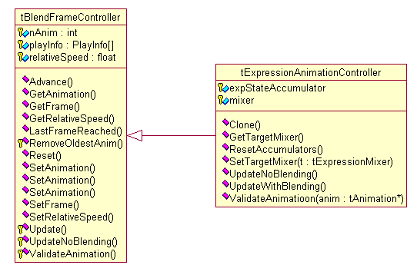
Figure 8 tExpressionAnimationController

Offsetlists and PrimGroups
For version 16, several changes have been made to the way offset data is represented in the tlSkin chunk. These changes were made to make it possible for PDDI to add vertex offsets to vertex positions in the graphics pipeline.
The following changes were made:
- All faces that have vertex offset data and share the same shader are exported to its own primgroup.
- Primgroups are ordered so that primgroups sharing the same shader are consecutive, such that the first one contains no offset lists and the second one contains offset lists.
- The offsetlists (tOffsetlist chunks) are now stored in a tlExpressionOffsetsChunk (a direct sub-chunk) of tlSkinChunk. See Figure 9.
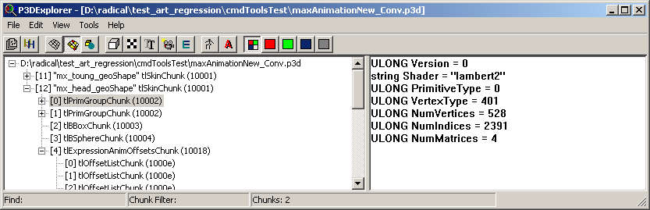
Figure 9 Offset data is stored in sub-chunks of the tlSkinChunk

Previously, offset lists were held by the tPrimGroup object. The tPolySkin has a pointer to a tExpressionOffsets object which is a container for all offset lists (tOffsetList) affecting the tPolySkin object .

Functional Scenarios
The current design is very flexible and allows considerable freedom in the way the expression system can be used. Two different approaches that have been used are:
- Enforce tight coupling of expression group and target skins by requiring each target skin to have a tExpressionGroup, a tVertexOffsetExpressionMixer , tExpressionOffset created at load time
- Loose coupling – all targets use one universal expression group,. In this case it is not necessary to export a tlExpressionGroup and a tlVertexOffsetExpressionMixer for each target skin. Run-time objects required by the expression animation system are created during the game execution
The first approach is simpler and less error-prone. It is the recommended approach.
The second approach, loose, coupling exploits the idea that all similar characters should use an expression template. It is conceptually elegant but can be error-prone if the character and the expression set do not matched. The errors caused by a mismatch are difficult to detect. No assertions will appear but the animation may be subtly different, or may fail to play at all.
Because the tVertexOffsetExpressionMixer chunk and the tlExpressionGroup chunks are relatively light-weight there is not much memory savings to be gained. However, in the case where the game has a very large number of characters that could potentially have facial expression but where only few facial animations play simultaneously, this approach might be appropriate.
Moreover, since facial expressions are only played for short intervals, interspersed by many minutes of game action, it is not ideal to have to load into inventory all the run-time objects required by the expression animation system for the entire level. It may be preferable to create instances of the tVertexOffsetExpressionMixer object dynamically.

Art Pipeline Considerations
An important consideration in the art pipeline is that expression animation is stored in a separately from its geometry. Currently there is no built-in mechanism that allows you to determine a head of time the expression group that matches an expression animation. An expression animation is validated only when you call tBlendFrameController::SetAnimation(). If the game uses multiple expression groups the art pipeline should provide a way to associate animation expressions with specific expression groups. Currently no programmatic solution is provided for this. However, this can be implemented by using a naming scheme.
Note also that although the each animation channel bears the name of the expression , for e.g. sad, happy, the ordering of the animation channels must match the order of the expressions in the expression group. An invalid ordering of animation channels can cause the animation keyframes for sad to be interpreted as happy! Because we do not sort the expressions on export, the relative positioning of the expressions in the p3d file may depend on the ordering of the Expression nodes in the Maya hypergraph . You should refrain from tweaking this or risk changing the order of the expressions.
If you enforce tight coupling of expression system objects (as described in the previous section), then every tCompositeDrawable that has facial expression should have one corresponding tlExpressionGroup, tlVertexOffsetExpressionMixer chunk.
Each expression group can a maximum of 32 expressions.

Future Work

Run-time
- PDDI support for applying vertex offset
  - Modify tVertexExpressionMixer so that it no longer stores neutral mesh vertices
  - Clean up tlPrimGroupSkinned so that it no longer stores temp positions (i.e. neutral mesh vertices)
- Modify run-time to compute vertex offsets on a per primgroup basis
  - Modify tVertexOffsetExpressionMixer::Update() so that it can compute vertex offsets for one primgroup at a time.
  - Modify the update method in tPolySkin to call the tVertexOffsetExpressionMixer :: Update
  - Remove or change GetVtxOffsets()
- API changes
We should reconsider whether users should be allowed to change the tVertexOffsetExpressionMixer’s target and expression groups at run-time. If we allow them do so we should look for ways to verify that an expression group and a target skin are well-matched . A possible solution is to compute a checksum at export time using the expression names and the number of keys in each expression. At run-time this checksum can be used to test whether the expression group, animation, and target mesh are well-matched.
If however we choose to require that the association between the target mesh and expression groups must be correct at load-time, and users cannot modify the association established by the tVertexOffsetExpressionMixer object, then we should remove the methods that permit this. These methods are the tVertexOffsetExpressionmixer::SetTarget( ) and tExpressionMixer::SetExpressionGroup() methods.
Regardless, users must still be able to dynamically create tFrameController objects and we should provide a robust way of verifying whether a frame controller ‘s target mixer object are suitable for animations to be played by it.

Toollib
We may need to provide a tolerance for splitting primgroups into set containing faces with no expression offsets and one that does based on some percentage. For example if the number of faces which have expression offsets is greater than 70% than do not split the primgroup. This could be a user-option or a hard-coded number that has been determined to be optimal for most cases.
Consider implementing a sorting scheme for exporting expression groups, and applying the same sorting scheme to the animation channels.

Feature Requests
- Keyable blend stage
This request should be considered. This feature will give the artist more freedom when composing a face shape from a set of expressions. The idea is to allow the artist to have control whether the expressions that contribute to the current face shape should be additive or averaged by modifying the blendstage the expressions at each keyframe.
To implement this feature we need to:
- Export the blend stage as a separate integer array for each animation group currently being exported. Provide UI to allow users to enter a blend stage for each expression that they are keying.
- Modify the tExpressionFrameController to provide the blend stage for each expression at each update loop in addition to the expression state.
- Modify the blend algorithm implemented in tVertexOffsetExpression:Mixer::Update().
- Linear interpolation of normals
Linear interpolation of normals is desirable to provide a more complete solution. Moreover there is a simple implementation that reuses the same blending and vertex offset calculation already implemented for points.
For each vertex point, we export a normal point that is the sum of the vertex point and the unit vector. Then, we perform the same blending and vertex offset calculation that is currently performed on vertex points on the normal points. Then get the unit vector given the vertex and normal points.
- Overridable float key field in Animation Tab
This UI feature should be implemented. Currently, the sliders on the Animation Tab of the Deformer plug-in are sized so that it is not possible to key negative values if no negative key has been defined for an expression (and vice versa for positive keys). Users would like to be able to override this by entering a negative float value in the slider key field.

Conclusion
The primary challenge in using the expression animation system effectively was the lack of information. Because the system depends on a large amount of disparate information the system can be challenging to understand. I hope this document has been helpful. The key to using the expression system (as it is currently designed) is to have a clear understanding of how the various data components: expression offsets, expression groups, animation are inter-related.
The Expression Animation System can also be seen as a specialized implementation for a more general problem of parameter-driven animation and event-driven animation. Instead of vertex offsets, this architecture could potentially be generalized to support interpolate and animate arbitrary attributes over time by deriving custom mixer classes from the tExpressionMixer class and building the supporting toollib and run-time functionality. It is possible to animate any continuous attribute whose value can be approximated using linear interpolation by adapting the Expression Animation System approach: A data chunk is used to define a set of keys that map to animatable attributes, a mixer implements the interpolation and blending, and a chunk which stores the actual animatable attributes .

Interesting Links
Expression Cloning (Featured in Computer Graphics World)
http://graphics.usc.edu/~junyong/papers/sig2001.pdf
This article describes the problems involved in retargeting facial animation data (based on vertex offsets) between different models.
http://www.gamasutra.com/features/20010418/moore_01.htm
This article describes an implementation of a facial animation system using Maya bones, and is therefore not directly relevant to our implementation. However, the third section is particularly interesting as it discusses how a characters expressions can be driven from a script file that specifies moods and the phonemes for a given sound clip.

